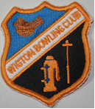 Wigton Bowling Club,West Road, Wigton CA7 9RG 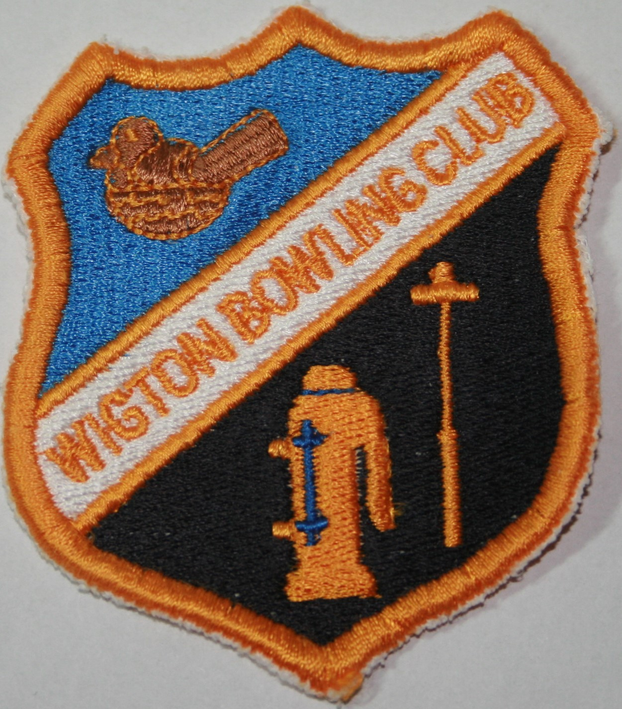

APPLICATION FOR MEMBERSHIP

I, …………………………………………………………………………………………..(FULL NAME)
Apply for:
FULL BOWLING
JUNIOR BOWLING (U/18yrs),
SOCIAL MEMBERSHIP
ASSOCIATE MEMBERSHIP of the above Club. (Please delete as appropriate)

Address: …………………………………………………………………………………

……………………………………………………………………………………

Post Code : …………………………. Email : ………………………………………………………

Telephone number : …………………………..

Signature of Applicant:

…………………........…...........................................................................................................
(please provide details of parent when applying for junior membership)

Date of Birth…………………………………

Date of Application…………………………..

For Official Use: Approved/Refused

Membership No………………………….. Membership Sec…………………………. Date

